2019 UPDATE TO COMMUNITY HEALTH NEEDS ASSESSMENT
HOSPITAL SERVICE DISTRICT #2
PARISH OF VERMILION
STATE OF LOUISIANA
D/B/A ABBEVILLE GENERAL HOSPITAL
November 27, 2019

Errol F. Greig, Jr. MBA-HCA, CHC, Compliance Officer
Ray A. Landry, FACHE, CEO

INTRODUCTION

In 2018, Abbeville General (AG) conducted a complete update of its Community Health Needs Assessment (CHNA). This assessment addressed the key characteristics and the environment in the local community. It also identified the areas where AG could focus attention and resources to improve the health status of the community. This document was updated in November 2019 to include completion of projects, changes in statistics, and the like.

This document will serve as an update to the established CHNA action items that were identified in the 2018 CHNA.

COMMUNITY HEALTH PARISH RANKINGS

The Community Health Parish Rankings is a component of the County Health Rankings & Roadmaps program, as a collaborative project between the Robert Wood Johnson Foundation and the University of Wisconsin Population Health Institute. The following is a summary report of that data, with the full report in table format at the end of this document, “Exhibit A.”

Vermilion Parish achieved an overall ranking of “13” in Health Outcomes and “23” in Health Factors”, out of the 64 parishes, with the lower number being preferred. Elements that contributed to the ranking in Health Outcomes (13) include: Length of Life (9) and Quality of Life (19). These were based on data values in relation to the following: premature death (prior to age 75); low numbers of surveyed individuals indicating poor/fair health and low number of days with poor/fair health; low number of days of poor mental health; and a low number of low birthweight (10%). All of these together give indication that the general population in Vermilion Parish is experiencing a “Quality of Life” that is better than most parishes state-wide. Health Factors (23) was based on the following: Health Behaviors (15), Clinical Care (29), Social & Economic Factors (23), and Physical Environment (37). Clinical Care has actually improved from the previous (43), allowing for the overall Health Factors number to improve as well With that being noted, there is still a need for areas of improvement, such as a need to increase access to primary care physicians, dentists, and mental health providers.

By studying this data healthcare providers, along with leaders in our community, can determine current effectiveness of programs and utilize available resources to make changes. This creates an opportunity for growth and improvement, while also recognizing current success. Despite Vermilion Parish having a strong standing when compared with parishes throughout the state, there are many areas that continue to need improvement. Healthcare providers and community leaders have an opportunity and a responsibility to develop and expand on outreach initiatives and focused education, in an effort to improve the health and wellbeing of everyone.
Based on analysis compiled from several sources, the following table exhibits the physician to patient ratio, considering current employed physician specialties at Abbeville General, as converted to reflect the population of Vermillion parish.

SPECIALTIES | GMENAC | GOODMAN | HICKS & GLENN | SOULCIENT | COMBINED AVERAGE | *NUMBER REQUIRED FOR VERMILION PARISH
Pediatrics | 12.8 | NA | 7.6 | 13.9 | 11.43 | 6.86
Family Practice | 25.2 | NA | 16.2 | 22.53 | 21.23 | 12.74
Gastroenterology | 2.7 | 1.3 | NA | 3.5 | 2.5 | 1.5
Anesthesiology | 8.3 | 7.0 | NA | NA | 7.65 | 4.59
Hematology/ Oncology | 3.7 | 1.2 | NA | 1.08 | 1.99 | 1.2
General Surgery | 9.7 | 9.7 | 4.1 | 6.01 | 7.38 | 4.43
Psychiatrist | 15.9 | 7.2 | 3.9 | 5.73 | 8.18 | 4.91
Cardiologist | 3.2 | 3.6 | 2.6 | 4.22 | 3.41 | 2.04
*Calculations adjusted based on current population estimate for Vermillion Parish of 60,000
Sources:
(Physicians required per 100,000 population)
GMENAC (Graduate Medical Education National Advisory Committee) GMENAC was a one-time, ad hoc committee of health care experts convened by Congress to assess U.S. health care manpower needs. In 1980, GMENAC issued estimates of the number of physicians needed per 100,000 population. No such estimates have been issued from the government or from government-sponsored agencies since. The GMENAC numbers are nearly 30 years old and are considered dated by many.
GOODMAN Writing in the December 11, 1996 issue of JAMA, David Goodman, MD, et al, project physician-per-population needs based on three different types of service populations: the patient panel of a large HMO, the population of a community with a high level of managed care, and the population of a mostly fee-for-service community. The numbers above reflect need in a mostly fee-for-service community.
HICKS & GLENN Writing in an 1989 edition of the Journal of Health Care Management, Hicks and Glenn, two PhD’s affiliated at that time with the University of Missouri School of Medicine, project physician-per-population needs based on the current rate of patient visits generated to particular specialists as determined by the Department of Health and Human Services’ National Ambulatory Healthcare Administration report divided by the number of patient visits physicians typically handle, as determined by the Medical Group Management Association.
SOLUCIENT Solucient (now Thomson Healthcare) is a health care consulting firm. Its numbers are based on a 2003 study and are, therefore, the most recent of the figures provided herein. Solucient employed a methodology similar to Hicks & Glenn which analyzed National Ambulatory Health Care Administration patient/physician visits data, Medical Group Management Association physician productivity data and private and public claims data showing patient/physician visit rates by age.

CHNA-IDENTIFIED PRIORITY HEALTH NEEDS

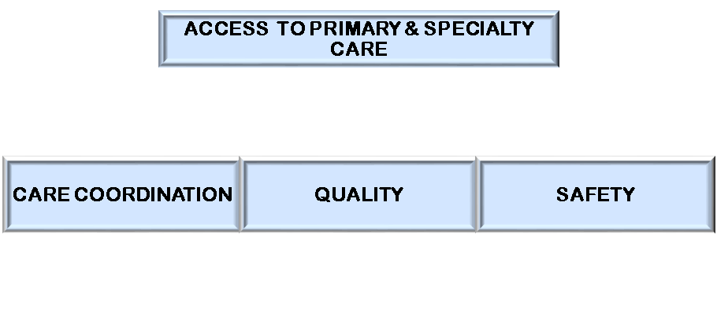

ACCESS

Medical Staff Development Plan

- Primary care providers – Family Practice Physicians and Primary Care Midlevel Providers have been recruited and assigned to increase healthcare services in the Rural Health Clinics (Patient-Centered Medical Home). These providers bring years of experience with a combination of services in internal medicine, family practice, pediatrics, and obstetrics and gynecology.
- AG has only one active medical staff member in General Surgery. The hospital has been able to add surgeons on a consulting basis to assist in responding to surgical needs. Recruitment efforts continue to obtain one full-time General Surgeon to assist in responding to the 24/7 nature of emergency call rotation and inpatient surgical needs. AG did add a Board Certified General Surgeon to its Courtesy staff. Patients can be seen at the Erath/Delcambre Community Care Clinic by this Provider. In anticipation of the need for increased surgical services, an additional surgery/operating room is planned for renovation and use in the near future.
- AG currently has only one active physician in Psychiatry. However, as of September 2019, Abbeville General has contracted with Signet to manage all Psychiatric services, which will include additional providers, as well as the use of telehealth services for Psychiatric services. This arrangement will continue to assure that a qualified practitioner will be available to respond to the 24/7 nature of emergency call rotation, inpatient psychiatric needs, outpatient psychiatric programming, and availability of services in our Rural Health Clinics, including home visits.
- Promotion of a collaborative effort with the LSU Health Sciences Center in New Orleans, LA, to referring physician offices and the general public. Telemedicine services have been obtained in the Abbeville Rural Health Clinic through the hospital’s affiliation with the LA Rural Health Information Exchange, representing a collaborative effort with the LSU Health Sciences Center.
- The Rural Health Clinics also plan to implement Primary Care home visits, and is in the final phase of planning/implementation of a Hepatitis Clinic in our Erath/Delcambre clinic, as the Louisiana Department of Health has strategized a statewide hepatitis C elimination campaign.

Rural Health Clinic

- In March of 2019, the RHC’s began utilizing a clinic nurse to make follow-up calls to patients with chronic conditions. The initial focus has been to assist patients with their self-management goals, with plans to expand on this program in the future.
- In 2019, one of Abbeville General’s RNs became a Certified Diabetes Educator, and is now providing related services in our Rural Healthcare Clinics.

Laboratory Services Outreach
- In addition to the main hospital site, access points for patients to receive laboratory services include the Rural Health Clinics, independent physician offices, and Offsite Imaging Center.

Emergency Department
- The Emergency Department recognizes the need to provide emergency services to all residents of its community, including low-income and needy patients, and provides these services regardless of a patient’s ability to pay. Of the 4,278 patients served by Abbeville’s emergency department, over 70% were charity, Medicaid, or self-pay patients.
Gastrointestinal Services Services Outreach
- At the beginning of 2019 Abbeville General announced the arrival and services of two Board Certified Gastroenterologists, offering ED call service and in-patient consultations, along with availability in our Rural Healthcare Clinics.

New Construction

- In March 2019, the state-of-the-art Behavioral Medicine Center (BMC), which is a dual-use Safe Room, was opened. The project began in the fall of 2016 and has produced a building that is 12,517 square feet and multi-functional. In its non-emergent use, the facility will serve as a 16-bed in-patient psychiatric unit. There is also an exterior covered space and connecting corridor/vestibule which was built with separate funds to tie in the building to the current hospital structure. This will protect both patients and staff from environmental elements. In the event of a parish emergency, the BMC will convert into a near-absolute life safety barrier and house all essential hospital services personnel and all first responders who will be needed in the community when the event is over. The safe room is able to withstand 180 mile per hour winds and is on a 500 year flood elevation.

- Currently, construction/renovation is underway in the Pharmacy department to accommodate a compounding room, to maintain compliance with United States Pharmacopeia (USP) 797/800 requirements.

Infusion Therapy Services Recognition

- A recent expansion has added two chairs, making a total of ten-chairs available in the Infusion Therapy Center, allowing for advanced chemotherapy administration. This Clinic exists on the third floor of AG through affiliation with the Cancer Center of Acadiana at Lafayette General Health System. Patients and their families need not travel elsewhere to receive these types of therapies but rather receive them close to home.

Surgical Services - Advanced Imaging Modalities

- Abbeville General recently invested in Stryker’s 1688 Advanced Imaging Modalities (AIM) 4K Platform. The 1688 AIM 4K Platform is a minimally invasive surgical tower that will now provide our surgeons with superior visualization and advanced imaging modalities across an array of specialties. The new all-in-one system features: 4K Image Resolution: Brilliant 4K resolution offers our surgeons crystal-clear images for improved visualization during surgery.

Diagnostic Imaging

- Abbeville General plans to add a second CT scanner in the Diagnostic Imaging Department. The GE Revolution Evo is a 32-slice helical system with the latest software, metal suppression, Cardiac Calcium Scoring, CT Angiography package and a 550 lb. weight table tolerance. This additional system will provide opportunity to schedule patients in a timelier manner. It will also enable scanning during a scheduled invasive procedure in CT Room #1, e.g. biopsy. This system will allow a continuous provision of CT services for scheduled exams, emergent exams and during downtime of a system due to repairs.

Accountable Care Organization / Affordable Care Act

- Through its Rural Health Clinic Network and hospital outpatient services located throughout the Hospital Service District, patients are afforded access to quality care close to home. The clinics meet the definition of patient-centered medical home as promulgated by guidelines through CMS, JC, LDH, and managed care contracting entities.

Uninsured Population Access to Care and Medications

- The hospital and its clinics offer financial assistance, to include medication. The financial assistance policy, which may be found on the hospital’s website, works in conjunction with the Medicaid Financial Application Center at AG and its clinics. This assures access to quality care regardless of patient income and ability to pay, as care can be based on the patient financial information utilizing approved guidelines referencing the poverty guidelines.

Clinically Integrated Network – Ochsner Health System

- Abbeville General provides charity services in the community. Certain physician and other professional services are provided to indigent patients in the community. Abbeville General has a collaboration with certain private hospitals in Louisiana. Together with these hospitals, Vermilion Health Services, Inc. was formed, which is a Louisiana non-profit corporation. More than $6.8 million in care has been provided to the indigent, including inpatient and outpatient services. Charity services provided in the community by Abbeville General include:
- Emergency Room Services: There is a need for low-income and financially disadvantaged patients to be serviced for emergency situations, and Abbeville General recognizes that need. Emergency services are provided for these patients regardless of their ability to pay. Of the 4,278 patients served by Abbeville General’s emergency department, over 70% were charity, Medicaid, or self-pay patients.
- Newborn Services: The State of Louisiana has one of the highest infant mortality rates in the nation. Abbeville General’s focus is on reducing this rate. Of the 57 newborn deliveries by AG in the quarter prior to March 2018’s Summary of Community Benefits percentage results, 84% were to charity, self-pay, or Medicaid patients.
- Psychiatric Services: Abbeville General provides psychiatric services to patients in need of psychiatric care regardless of their ability to pay. Of the 112 patients that were treated by Abbeville in the quarter prior to the results of March 2019’s Summary of Community Benefits, almost 69% were charity, self-pay, or Medicaid patients.
- Recruitment and Expansion of Services: Between February and April 2019, Abbeville General added two physicians to its Diagnostic Radiology Program and two physicians to its Gastroenterology Program. Abbeville General also made almost $1.7 million in capital improvements to be able to better serve its patient population.
- Education and Outreach: Abbeville General participated in multiple outreach initiatives aimed at improving health, education, and community involvement. The following are a list of some of these:

  - Abbeville held a free prenatal classes at the hospital on December 10 and January 30. Abbeville physicians provided information about baby care and breastfeeding to the public.
  - At the Vermilion Chamber of Commerce Luncheon on December 13, Abbeville brought unwrapped gifts for children in need an gave a presentation regarding “Urgent Care for Everyone.”
  - Abbeville participated in two United Way events this quarter, a January 9 Community Conversation at the Vermilion Parish Library and a Community Education event on December 5. At the event Abbeville’s infection control nurse spoke to the 3 year olds, parents and the workers about the importance of hand hygiene. Participants learned when wash your hands, how to wash your hands, ways to get kids engaged in washing hands.
  - Abbeville helped coordinate the December 14 Christmas Party for Foster Children. The event provided over 300 gifts food, and activities for foster families.
  - Beginning on March 29, 2019, the Abbeville’s Rural Health Clinics began utilizing a clinic nurse to make follow-up calls to patients with chronic conditions. The initial focus has been to assist patients with their self- management goals, and Abbeville anticipate expanding the focus in the near future.
  - At the Fishermen Meeting at the LSU Ag Center on March 19, the Community Health Fair held at the Vermilion Parish Library on April 10, and the Vermilion Wellness Expo held at the Abbeville High School gym, Abbeville’s Community Events Committee provided free health screening to participants, including PSA, blood pressure, blood cholesterol, blood glucose, and BMI. Participants were given information on Abbeville’s Rural Health Clinics, extended Urgent Care Clinic hours, and were scheduled with a health care provider for further health screening, in addition to nutritional counseling regarding healthy eating.
  - Abbeville sponsored the Mardi Gras Ball held by the Vermilion Council on Aging on February 22, and provided promotional items and brochures regarding services available at Rural Health Clinics to participants.
  - Abbeville held a free prenatal classes at the hospital on February 27. Abbeville physicians provided information about baby care and labor and delivery to the public.
  - Abbeville’s physicians held a presentation regarding the opioid epidemic at the hospital, free to healthcare workers in Vermilion Parish.
  - On March 29, Abbeville partnered with the Junior Auxiliary and the LSU Ag Center to bring health information, activities, healthy snacks, to all students at Eaton Park Elementary during the Junior Auxiliary’s HAPPY event at Eaton Park.
  - Abbeville’s Human Resources department participated in the Vermilion Parish Job Fair on April 17. The booth contained information about Abbeville’s value added services, RHCs, Urgent Care, medical specialties, and current job opportunities.

QUALITY

Patient-Centered Medical Home and Accreditation by Joint Commission

- The Rural Hospital Clinics in Erath-Delcambre, Abbeville, and Maurice achieved Patient- Centered Medical Home (PCMH) accreditation status in 2014.

Relentless Pursuit of Quality Care of Value for Patients
- Through aggressive maintenance of a leadership dashboard which monitors various quality measures, the leadership of the Hospital Service District has set benchmarks to achieve higher than state and national measures of performance in clinical processes of care, patient experience of care, and patient outcomes of care. For 2019, the Hospital Service District performance score is 49.58, as compared to a state score of 37.27, and a national score of 38.51. As a result of this high score, the Hospital Service District will receive a value-based incentive payment percentage of 2.78% for 2020.

Readmissions Collaborative Between Inpatient Care Units and the Rural Health Clinics

- To improve the readmission rates for certain diagnoses, the Hospital Service District has undertaken significant care coordination initiatives to lower the hospital’s overall readmission percentage lower than the national benchmark. A case management program is in place to coordinate the efforts of social workers, utilization review coordinators, nurses, and physicians to improve on core measure performance, utilizing evidence-based medicine practices. The end result is better-coordinated care and lower readmission rates.

Standards of Behavior Full Implementation

- A new approach to facilitate accountability, communication, courtesy, excellence in service, and professionalism/privacy (ACCEPT) has been adopted by all associated with the Hospital Service District to improve access to quality care close to home. Patient Safety Leapfrog scores, Value-Based Purchasing scores, Joint Commission and DHH Survey of Standards results are evidence of the success of ACCEPT standards implementation.

Human Resources Core Staff / Ongoing Commitment to Learning / Restructuring of Management

- All units have researched national and regional benchmarks which define staff guidelines to assure care which is safe, effective, timely, efficient, equitable, and patient-centered according to the Institute of Medicine objectives. Competent care/service related to staffing is an ongoing performance improvement monitor for all care and service units of the district.
- A management level restructuring was recently put in place to better position the hospital service district in a new health care delivery system model. As a result of the restructuring, the following appointments were made: Chief Financial Officer, Chief Nursing Officer, Chief Quality and Patient Safety Officer, and Chief Medical Officer, along with Support Services Director, and Account Executive/Network Development/I.T. Director.

PATIENT
SAFETY

Safety Star Award
- In 2019, Abbeville General was recognized for winning the Louisiana Hospital Association (LHA) Safety Star Award for patient safety initiatives. Each year, LHA presents the Safety Star Award to three healthcare facilities who have successfully implemented ideas or processes that have improved patient safety. The objective of the LHA program is to acknowledge members of the LHA who are committed to quality and safety and who have developed innovative ideas that improve patient safety within their facility. Abbeville General will receive recognition at the LHA Summer Conference in Gulf Shores, Alabama. Abbeville General coveted their award by implementing safety tools and processes to prevent patient elopements. Security technology in the newly constructed Behavioral Medicine Center (BMC) and the Emergency Department has allowed Abbeville General to reach a goal of ZERO elopements, which has been sustained for over 6 months! This accomplishment reduces risks to patients as well as employees while improving the environment and quality of care.

Compliance / Excellence Recognition

- AG has been awarded a three-year term of accreditation in Mammography as the result of a recent review by the American College of Radiology (ACR). Mammograms are used as a screening tool to detect early breast cancer in women experiencing no symptoms. They can also be used to detect and diagnose breast disease in women experiencing symptoms such as a lump, pain, skin dimpling, or nipple discharge. The ACR gold seal of accreditation represents the highest level of image quality and patient safety. It is awarded only to facilities meeting ACR Practice Parameters and Technical Standards after a peer-review evaluation by board-certified physicians and medical physicists who are experts in the field
- AG has been awarded a renewal for a three-year term of accreditation in MRI on March 11, 2019 as the result of a recent review by the American College of Radiology (ACR). MRI’S are used as a tool to detect and diagnose numerous abnormalities, to include but not limited to herniated disk disease, cerebral hemorrhage, vascular disease, bone disorders, biliary system abnormalities and tumors from cancer of all body systems in conjunction with other imaging modalities. The ACR gold seal of accreditation represents the highest level of image quality and patient safety.
- Based on January 2019 results, Abbeville General earns 4 out of 5 stars for their overall hospital rating, according to Medicare.gov, the Official U.S. Government Site for Medicare. Only 23.75% of hospitals, nationally, have achieved this 4 star rating, while just 6.41% have earned 5 stars. The overall hospital rating summarizes a variety of measures on Hospital Compare reflecting common conditions that hospitals treat, such as heart attacks or pneumonia. Hospitals may perform more complex services or procedures not reflected in the measures on Hospital Compare. The overall hospital rating shows how well each hospital performed, on average, compared to other hospitals in the U.S.
- AG was presented with the Business of the Year Award by the Vermilion Chamber of Commerce at the Annual Installation & Membership Social on January 30th. This award honors one business that demonstrates support of the business community, Chamber programs and workforce initiatives.

Evidence-Based Medicine and Healthcare Provider Competence

Through the FMEA process, the entire staff is charged with adopting best practices, developed and based on current national standards of performance and evidence-based medicine. In addition, all staff members must have a desire to pursue ongoing learning in regards to their professional work relationships, associations, and affiliations.

Leadership Dashboard National Benchmark Achievement

On an ongoing basis, the leadership of the service district, through all staff, have established benchmarks for performance in the areas of core measures for acute myocardial infarction; heart failure; pneumonia; surgical improvement project; hospital outpatient measures; stroke; venous thromboembolism; perinatal care; hospital-based psychiatric service; value-based purchasing; emergency department performance; employee health; human resources; infection control; medication use; mortality review; national patient safety goals; operative procedure review; patient falls; patient rights; patient restraint and seclusion utilization; risk management; patient satisfaction; utilization management, including readmission data; and financial indicators. Through an ongoing, concurrent process, the hospital establishes benchmarks as a group and monitor achievement to exceed state and national performance levels.

Level Two WellSpot

AG was designated a Level Two WellSpot by Louisiana’s Department of Health and Hospitals for its commitment to making healthy choices easier. WellSpots are organizations or companies that have made small, sustainable changes toward improving overall health and wellness. Well-Ahead Louisiana was the first voluntary designation program of its kind in the state. It encourages organizations and individuals to make small healthy lifestyle changes to spaces where Louisiana residents spend most of their time. Well-Ahead began in early 2014 and since then has designated WellSpots in every parish throughout Louisiana.

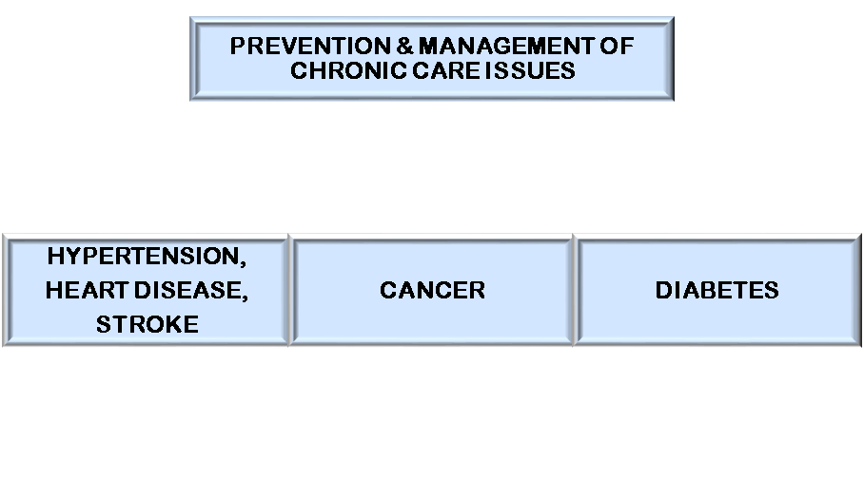
PREVENTION

  - Performed in AG’s Outpatient Surgery Program, colonoscopy is one of the most frequently performed procedures. Screening for and follow-up of colorectal cancer are among the indications for colonoscopy. Although colorectal cancer is highly preventable, it is the second most common cancer and cause of cancer deaths in the U.S. Both men and women face a lifetime risk of nearly 6% for the development of invasive colorectal cancer. Proper screening can help reduce mortality rates at all ages, and colonoscopy plays an important role in this effort. Compared with other imaging modalities, colonoscopy is especially useful in detecting small lesions; however, the main advantage of colonoscopy is that it allows for intervention because biopsies can be taken and polyps removed.
  - AG provides screening opportunities, including colon cancer screening, prostate screening, and mammograms. Free breast cancer screenings are conducted annually in the AG Rural Health Clinic. Free breast exams are performed by a physician, a physician’s assistant, or a nurse practitioner for women ages 40 – 64. Free mammograms are performed on women ages 40 – 64 who have not had a mammogram in the past 12 months. Services are free of charge for women who have no insurance and who meet an income requirement.
- Located on the third floor of the hospital, Sleep Center at Abbeville General provides overnight sleep studies for evaluation and diagnosis of obstructive sleep apnea (OSA) and other sleep disorders. Results of studies lead to patient education, follow-up, and treatment.
- Home Sleep Studies are now offered by the Sleep Center at Abbeville General. A sleep device collects information related to how much and how well a patient breathes at night. Respiratory nasal airflow, snoring blood oxygen saturation, pulse and respiratory effort during sleep are recorded. The device uses the recordings to produce a report for the healthcare professional that may aid in the diagnosis of sleep-disordered breathing or for further clinical investigation.
- The immunization measures were developed as a result of recommendations from a National Quality Forum Harmonization Workgroup that influenza and pneumococcal vaccination measures should apply to all patients regardless of diagnosis. Abbeville General offers the influenza and pneumococcal vaccines to consenting patients prior to discharge, and encourages pregnant women and mothers with infants to receive recommended vaccines. All personnel of AG are offered and encouraged to receive the influenza vaccination to protect the employee, their patients, and communities. Vaccination is also provided to immediate family members of AG employees. The service is free to employees and immediate family members. Outreach is also done to several community groups by offering the influenza vaccine.
- The optimal time to vaccinate the birthmother with Tdap is 27-36 weeks gestation. This will allow the antibodies to be carried on to the newborn and protect him/her for the first 3 months of life until vaccination is possible. The hospital begins the process in the Women’s Clinic. The records, including vaccination status, are forwarded to the OB department at the time of delivery, thereby documenting proof in the event that the mother does not recall receiving the vaccination. The father is channeled through the RHC. This assists the hospital with having an encounter record in the event that the father has a reaction. The hospital encourages and educates on the RHC’s abilities to vaccinate. For those OB/GYNS who are not employed by the hospital, their patients are also screened on admit for delivery and vaccinated after delivery if not previously done in the physician’s office.
- AG operates a 16-bed Behavioral Medicine Center which provides a caring supportive environment specially designed to meet the emotional health needs of adults, 18 and older. Additionally, the Partial Hospitalization Program and Intensive Outpatient Program provide intensive psychiatric treatment on an outpatient basis to improve a patient’s level of functioning and reduce symptoms to prevent relapse or hospitalization.
- A sepsis protocol has been developed and put in place. The protocol is based on early recognition through active surveillance of both those presenting through the Emergency Department and those developing nosocomial infections or suspected infections within the inpatient units at AG. The premise for creating the protocol is to lower the rate of progression and mortality by administering an organized and targeted treatment approach as efficiently as possible.
  - A Readmission Team was appointed to develop approaches aimed at arming patients with coping skills in managing their conditions after discharge from the hospital and to avoid the deterioration in their health status which occasioned readmission to the hospital.

Community Outreach Activities 2016-2017

- Suicide Prevention Event held in Magdalen Square, hosted by Abbeville General entitled “Making Each Day Count: Suicide Prevention & Mental Health Awareness Event.”
- Abbeville General participated in the JA/Chamber School Supply Drive, which was held to benefit Elementary and Middle Schools.
- Vermilion Children’s Expo: Back-to-School Health and Wellness Fair was held at the Vermilion Parish Health Unit. Abbeville General was a participating sponsor of the event which was focused on children from ages 0-8 years old. Health screenings were provided as well as information and resources for parents and guardians.
- Toys-for-Tots Drive.
- Giant Omelet 5K/2 Mile Fun Run.
- Links des Pink (Cancer Organization) Annual Golf Tournament: Vermilion Oaks Country Club, Abbeville, sponsor.
- Parent Advisory Meeting for Vermilion Parish Parents, VP Library, Abbeville, participant/sponsor.
- Fit 4 Life Vermilion Focus Group: 2-year completion event, AGH Employees, and public were invited to participate.
- Vermilion Parish Learning Garden: Eaton Park Elem., assisted in planting seeds and plants
- Levy Cancer Foundation annual Gala: Abbeville, sponsor.
- Assist Resource Fair: St. Theresa Catholic Church, Abbeville, participant.
- Snap Fitness 5K/Walk: Maurice, to benefit Links des Pink Cancer Organization, sponsor, provided drinks and trail mix.
- Council on Aging Health Fair – Senior; Promos; Clinic information.
- Chamber of Commerce Meetings - represented AGH Philanthropy Luncheon in Lafayette- organized table seating and submitted ads.
- Christian Service Center 5K and Festival – Fundraiser for the CSC who services the needy in Vermilion; BMI; healthy snacks; assisted in timing runners.

Community Outreach Activities 2018

- Parent Academy Seminars at VP Library-5:30-7:00 pm-Promote AGH and assist in the education of public school parents/guardians with parenting skills.
- Chamber-“Meet & Greet” at Langlinais, Broussard CPAs (Abbeville)-Represented AGH.
- Chamber Installation and Banquet -6:00-9:00 pm- Represented AGH.
- Nurses Skills Fair- AGH 7:00 am-6:00 pm Mandatory Skills fair for all RNs and LPNs at AGH.
- Beignet Boogie 5K – MC Elementary Open to the public (sponsor).
- Harvest Time Church Health Fair – 6:00 pm-7:00 pm; open to the public; Free Blood Cholesterol, Glucose, Blood Pressure, BMI Screens; Clinic information distributed.
- Dept. of Education Seminar for Vietnamese & Hispanic Community – Open to Vietnamese and Hispanic Communities; inform about AGH Clinics and Flu precautions/proper hygiene–translators used.

CHRONIC DISEASE MANAGEMENT

Care Coordination

- AG provides various courses according to American Heart Association standards. Course offerings include Basic Life Support (BLS), Advanced Cardiac Life Support (ACLS), and Pediatric Advanced Life Support (PALS).
- AG is a participating hospital in the LA Emergency Response Network, which is charged with the responsibility of developing and maintaining a statewide system of care coordination for patient suddenly stricken by serious traumatic injury or time-sensitive illness (such as heart attack or stroke).
- AG and Lafayette General Medical Center formed a partnership to provide advanced cancer treatment in the Cancer Center of Acadiana at Abbeville General. The enhanced services provided by the Center include a board-certified oncologist and collaboration with Lafayette General’s Radiation Oncology Unit, and the Infusion Therapy Center located in the Cancer Center provides intravenous infusion treatments and injections including chemotherapy.
- Services of the hospital include an interventional pain therapy/management clinic. The clinic provides therapeutic outpatient services for individuals experiencing pain in the lower back and lower extremities.
- AG is an affiliate of Our Lady of Lourdes Regional Medical Center’s Louisiana Stroke Network. The network is a collaboration of local hospitals working in concert to provide the most comprehensive stroke care in Louisiana and lowering the mortality rate and lasting effects of disability caused by a stroke in the community. The affiliation provides acute stroke management protocol in the Emergency Department and offers the ED physicians 24/7 access to a neurologist via the Telestroke Robot System.
- AG’s Rural Health Clinics in Abbeville, Maurice, and Erath/Delcambre provide Coumadin (Anticoagulation) Clinic services. The service monitors and manages the medication(s) taken to prevent blood clots. Coumadin (Warfarin) can be a dangerous medicine if not closely monitored. While on Warfarin, the blood clotting time or INR must be checked at least once a month, but more often when first starting the medicine when changes are made to other medications, or if the INR results are not within the therapeutic range.
- Services of Abbeville General include Diabetes / Nutrition Outpatient Services, which include a Diabetes Self-Management Training (DSMT) and individualized Medical Nutrition Therapy (MNT).
- The Maurice Community Care Clinic provides the services of a nephrologist one day a week, with on-call services/availability to the hospital 24/7.

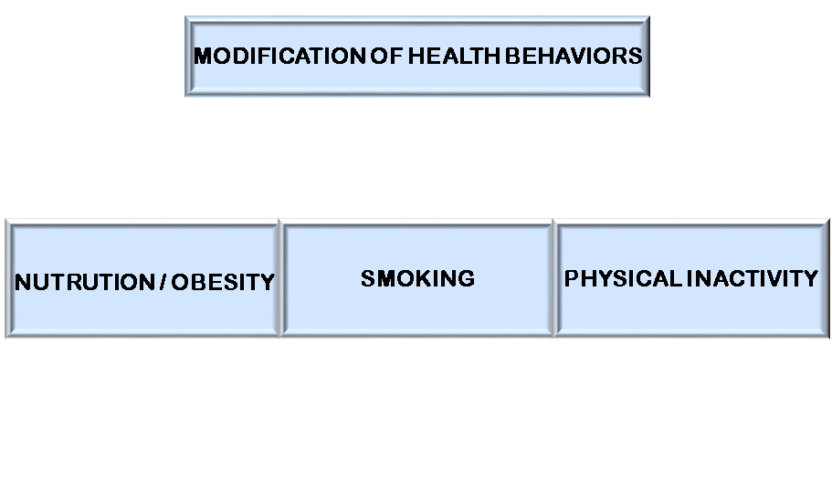

  - AG Employee Wellness Day.
  - Participation in Vermilion for Heart Health & Wellness Expo.
  - Member of Fit 4 Life Vermilion Support Group.
  - Partnership with Vermilion Parish School Board- Wellness Wednesdays three parish schools; Wellness Expo in Magdalen Square; Smoking cessation group; Wednesday workouts in Erath; walking in Godchaux Park three days per week; information on AG and clinics in employee mailboxes.
  - Fit 4 Life Vermilion Focus Group/Support Group – Vermilion Obesity Outreach.
  - Smoke-free, tobacco-free campus campaign.
  - Teamed with Vermilion Parish businesses to focus on obesity awareness.
  - In 2017, Abbeville General Employees created the One-Mile Happy Walk, an informal 15-minute session where employees get together, walk around the hospital and enjoy laughs and conversation while exercising.

Exhibit A

COMMUNITY HEALTH
PARISH
RANKINGS

Vermilion (VE)
Parish Demographics
 |  | Parish | State

Population |  |  |  |  |  | 60,136 | 4,684,333
% 65 and older |  |  |  |  |  | 14.9% | 14.9%
% Non-Hispanic African American |  |  |  |  |  | 14.3% | 32.1%
% American Indian and Alaskan Native |  |  |  |  |  | 0.4% | 0.8%
% Asian |  |  |  |  |  | 2.3% | 1.9%
% Native Hawaiian/Other Pacific Islander |  |  |  |  |  | 0.0% | 0.1%
% Hispanic |  |  |  |  |  | 3.6% | 5.2%
% Non-Hispanic white |  |  |  |  |  | 78.1% | 58.7%
% not proficient in English |  |  |  |  |  | 2% | 1%
% Females |  |  |  |  |  | 51.5% | 51.1%
% Rural 54.6% 26.8%

 |  | Vermilion  Parish |  | Error  Margin | Top U.S.  Performers | Louisiana | Rank (of 64)
Health Outcomes |  |  |  |  |  |  | 13
Length of Life |  |  |  |  |  |  | 9
Premature death |  | 8,200 |  | 7,400-9,000 | 5,400 | 9,500
Quality of Life |  |  |  |  |  |  | 19
Poor or fair health |  | 18% |  | 18-19% | 12% | 21%
Poor physical health days |  | 3.9 |  | 3.7-4.1 | 3.0 | 4.1
Poor mental health days |  | 4.5 |  | 4.3-4.7 | 3.1 | 4.2
Low birthweight |  | 10% |  | 9-11% | 6% | 11%
Additional Health Outcomes (not included in overall ranking) −
Life expectancy |  | 77.1 |  | 76.3-77.8 | 81.0 | 76.1
Premature age-adjusted mortality |  | 410 |  | 380-440 | 280 | 450
Child mortality |  | 60 |  | 40-80 | 40 | 70
Infant mortality |  | 6 |  | 4-9 | 4 | 8
Frequent physical distress |  | 12% |  | 11-12% | 9% | 12%
Frequent mental distress |  | 13% |  | 13-13% | 10% | 13%
Diabetes prevalence |  | 11% |  | 9-14% | 9% | 12%
HIV prevalence |  | 175 |  |  | 49 | 505
Health Factors |  |  |  |  |  |  | 23
Health Behaviors |  |  |  |  |  |  | 15
Adult smoking |  | 20% |  | 19-20% | 14% | 23%
Adult obesity |  | 36% |  | 30-42% | 26% | 35%
Food environment index |  | 8.1 |  |  | 8.7 | 5.3
Physical inactivity |  | 30% |  | 26-36% | 19% | 29%
Access to exercise opportunities |  | 62% |  |  | 91% | 75%
Excessive drinking |  | 20% |  | 19-20% | 13% | 18%
Alcohol-impaired driving deaths |  | 45% |  | 37-52% | 13% | 34%
Sexually transmitted infections |  | 430.9 |  |  | 152.8 | 679.3
Teen births |  | 39 |  | 36-43 | 14 | 37
Additional Health Behaviors (not included in overall ranking) −
Food insecurity |  | 13% |  |  | 9% | 17%
Limited access to healthy foods |  | 2% |  |  | 2% | 10%
Drug overdose deaths |  | 16 |  | 11-23 | 10 | 21
Motor vehicle crash deaths |  | 18 |  | 14-22 | 9 | 17
Insufficient sleep |  | 36% |  | 35-37% | 27% | 39%
Clinical Care |  |  |  |  |  |  | 29
Uninsured |  | 13% |  | 11-14% | 6% | 12%
Primary care physicians |  | 2,740:1 |  |  | 1,050:1 | 1,500:1
Dentists |  | 3,760:1 |  |  | 1,260:1 | 1,840:1
Mental health providers |  | 3,010:1 |  |  | 310:1 | 340:1
Preventable hospital stays |  | 4,480 |  |  | 2,765 | 5,960
Mammography screening |  | 38% |  |  | 49% | 39%
Flu vaccinations |  | 39% |  |  | 52% | 41%
Additional Clinical Care (not included in overall ranking) −
Uninsured adults |  | 17% |  | 15-19% | 6% | 15%
Uninsured children |  | 4% |  | 3-5% | 3% | 3%
Other primary care providers |  | 2,405:1 |  |  | 726:1 | 1,174:1
Social & Economic Factors |  |  |  |  |  |  | 23
High school graduation |  | 94% |  |  | 96% | 78%
Some college |  | 41% |  | 37-46% | 73% | 57%
Unemployment |  | 6.0% |  |  | 2.9% | 5.1%
Children in poverty |  | 24% |  | 17-31% | 11% | 28%
Income inequality |  | 5.1 |  | 4.3-6.0 | 3.7 | 5.7
Children in single-parent households |  | 41% |  | 34-47% | 20% | 44%
Social associations |  | 6.1 |  |  | 21.9 | 9.6
Violent crime |  | 387 |  |  | 63 | 541
Injury deaths |  | 71 |  | 61-80 | 57 | 84
Additional Social & Economic Factors (not included in overall ranking) −
Disconnected youth |  | 12% |  | 5-19% | 4% | 11%
Median household income |  | $50,600 |  | $46,800-54,300 | $67,100 | $46,300
Children eligible for free or reduced price lunch |  | 63% |  |  | 32% | 63%
Residential segregation - Black/White |  | 54 |  |  | 23 | 56
Residential segregation - non-white/white |  | 52 |  |  | 15 | 51
Homicides |  | 7 |  | 5-10 | 2 | 12
Firearm fatalities |  | 15 |  | 11-21 | 7 | 20
Physical Environment |  |  |  |  |  |  | 37
Air pollution - particulate matter |  | 9.4 |  |  | 6.1 | 9.4
Drinking water violations |  | Yes
Severe housing problems |  | 14% |  | 12-16% | 9% | 16%
Driving alone to work |  | 81% |  | 77-85% | 72% | 83%
Long commute - driving alone |  | 39% |  | 35-43% | 15% | 33%
Additional Physical Environment (not included in overall ranking) −
Home ownership |  | 77% |  | 75-78% | 80% | 65%
Severe housing cost burden |  | 8% |  | 6-10% | 7% | 14%
Note: Blank values reflect unreliable or missing data

